**Name: Ayush Agrawal**

**Date: 20-02-2022**

**SPRING SECURITY ASSIGNMENTS**

1) Design and develop a Spring security Hello World application by using default login form provided by spring security to secure URL access say, for example to access the content of an “admin” page, user needs to enter valid credentials. User must also logged out if successfully logged in.

Use Java Based and annotation-based configuration and In-memory authentication.

**Controller.java**

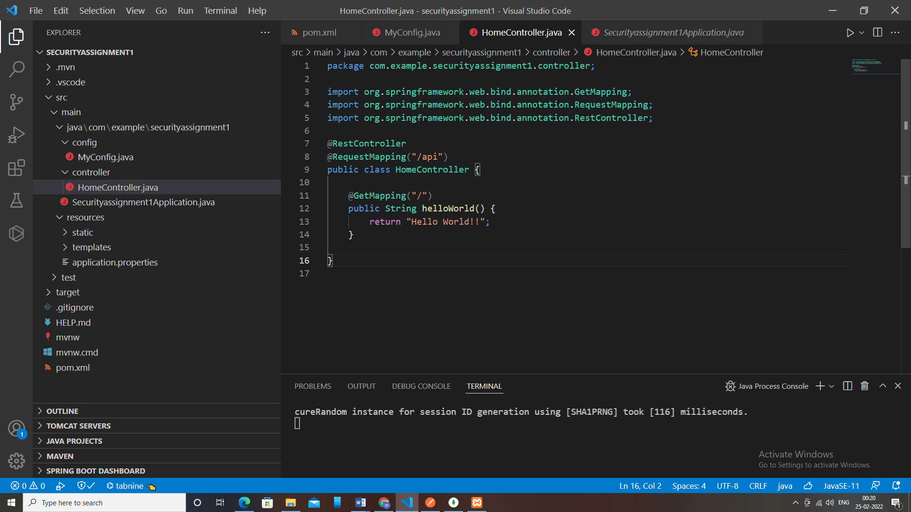

**MyConfig.java**

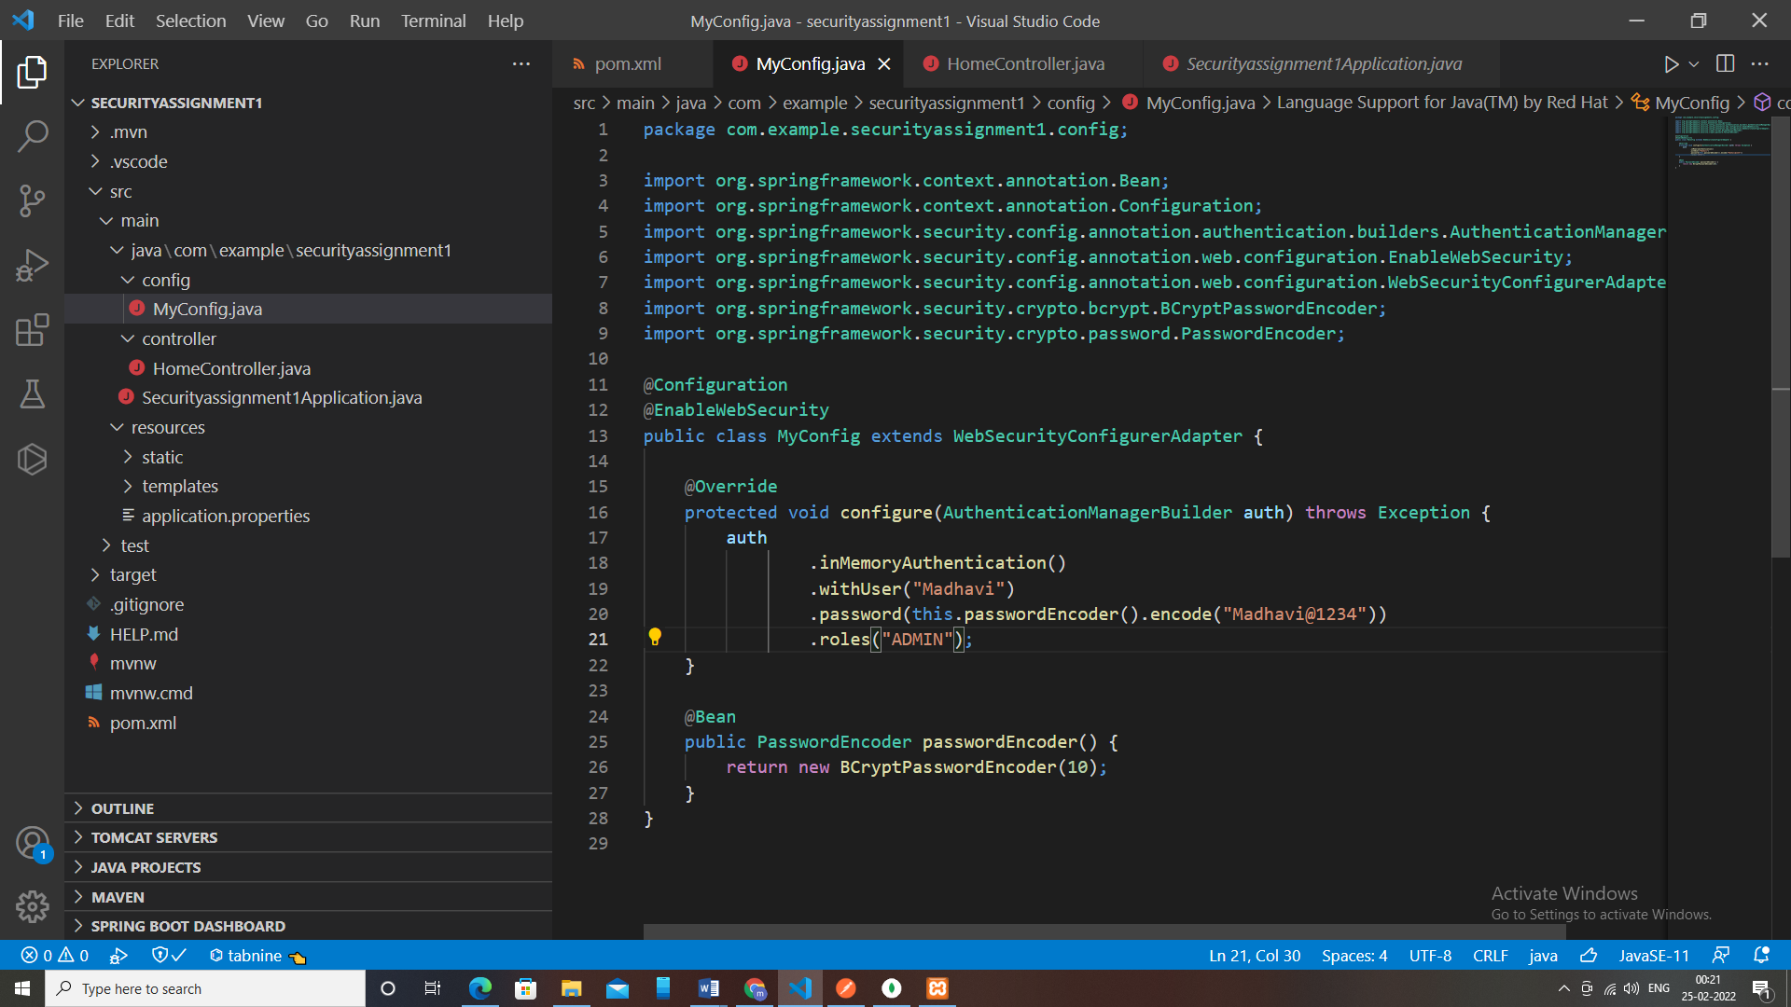

**API Testing:**

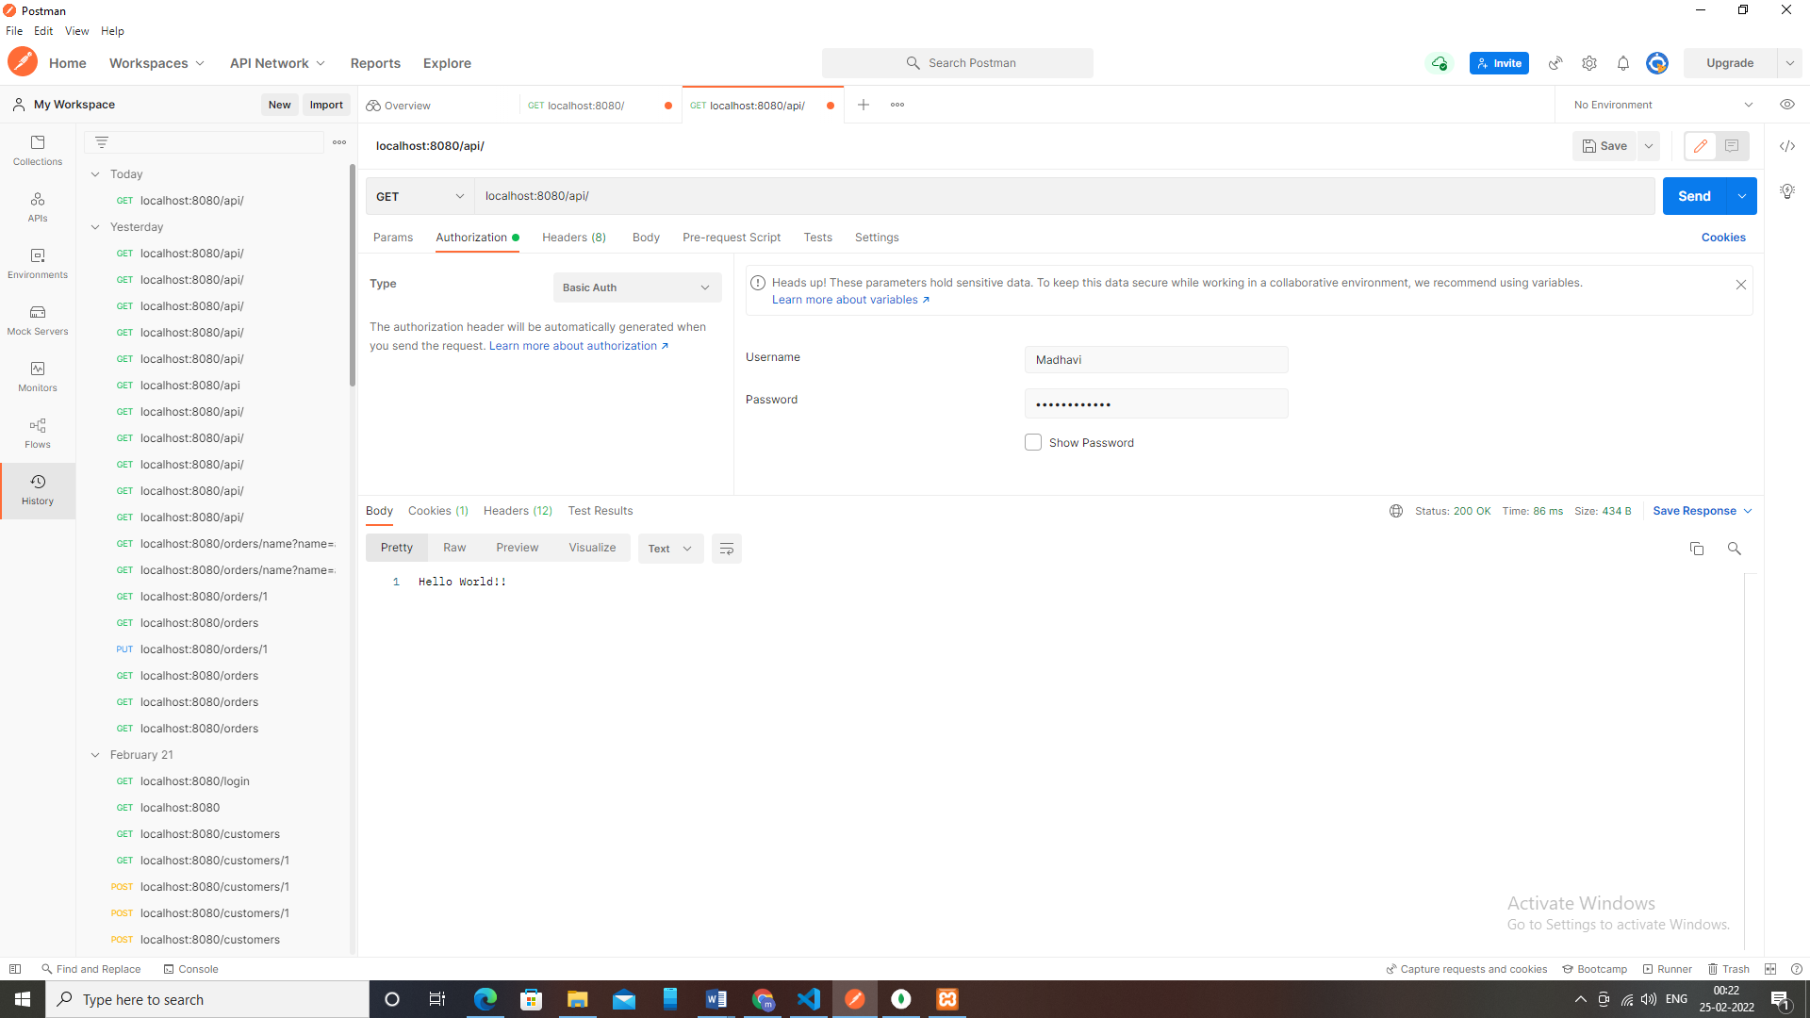

**Sign-in:**

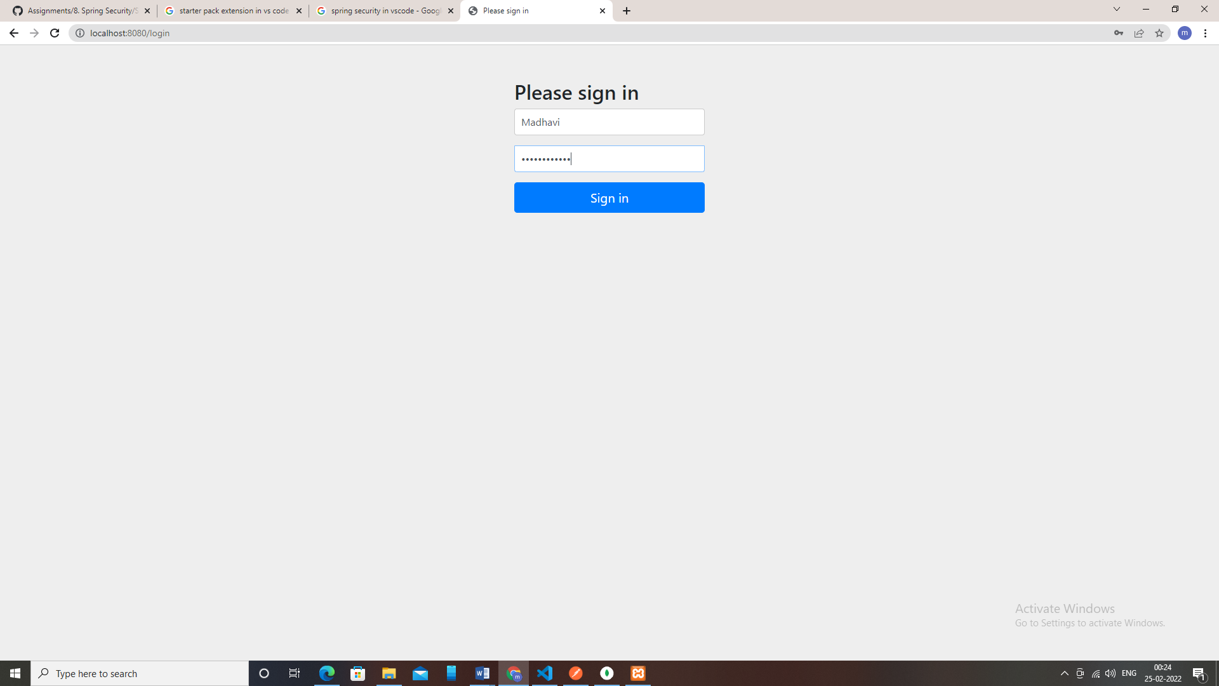

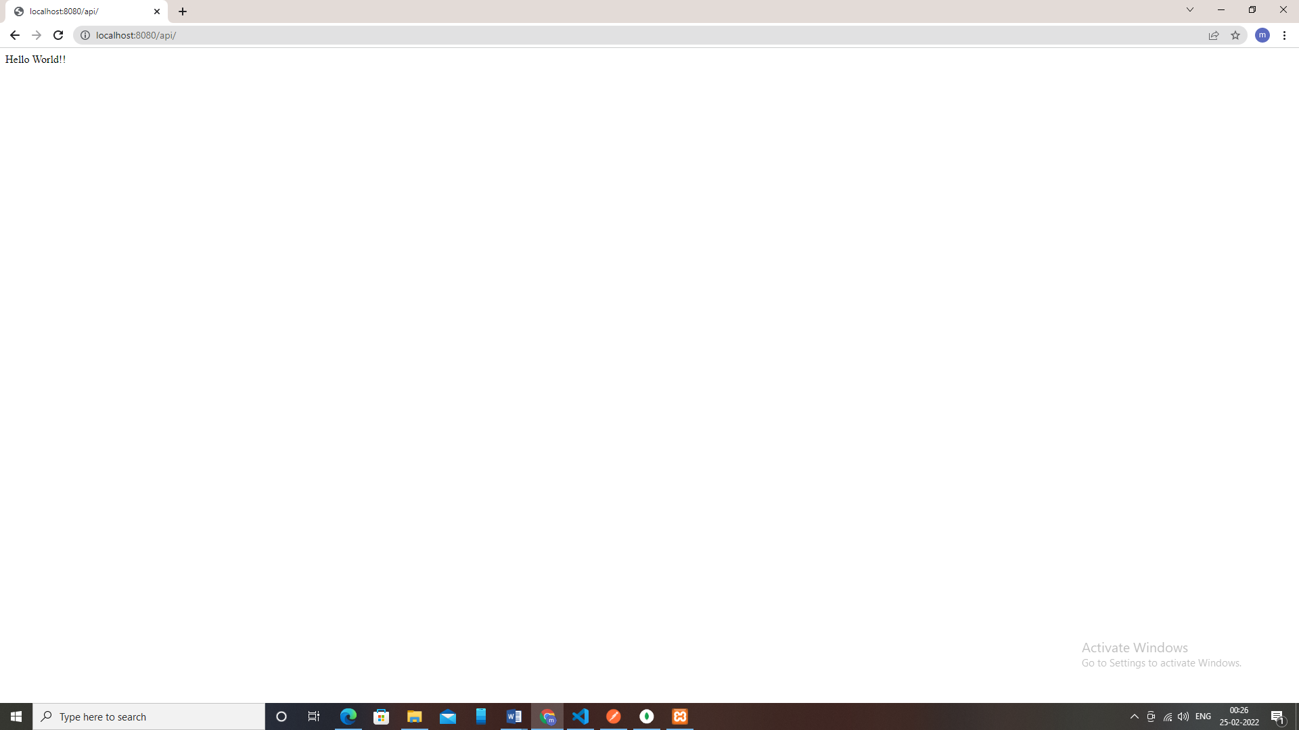

**Logout:**

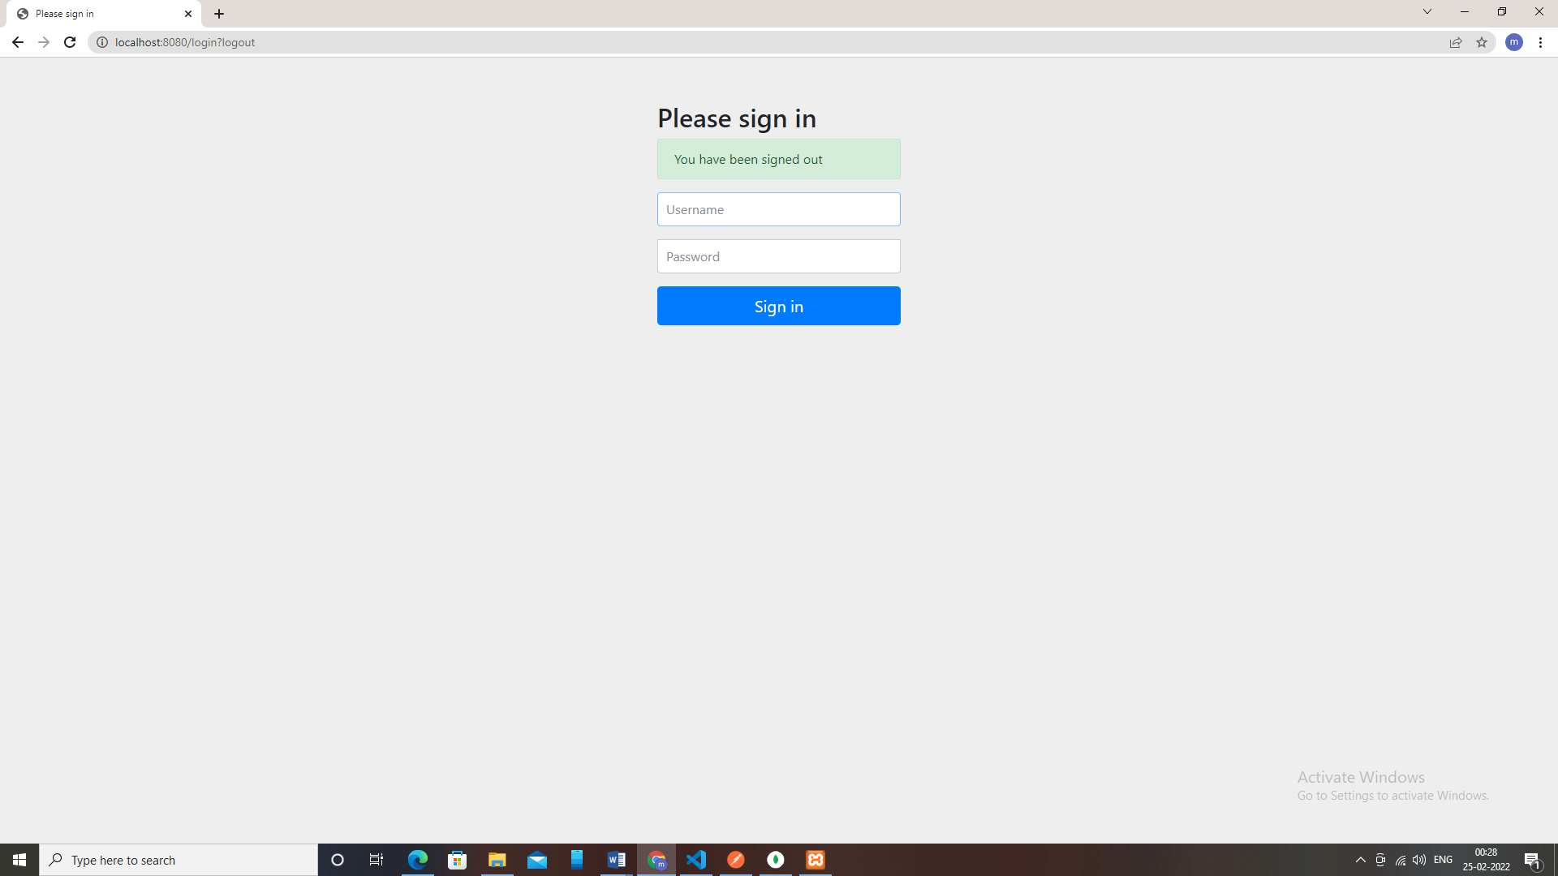

2) Modify the above application to use custom login form instead of default login form provided by spring security.

Use Java Based and annotation-based configuration and In-memory authentication.

**HomeController.java**

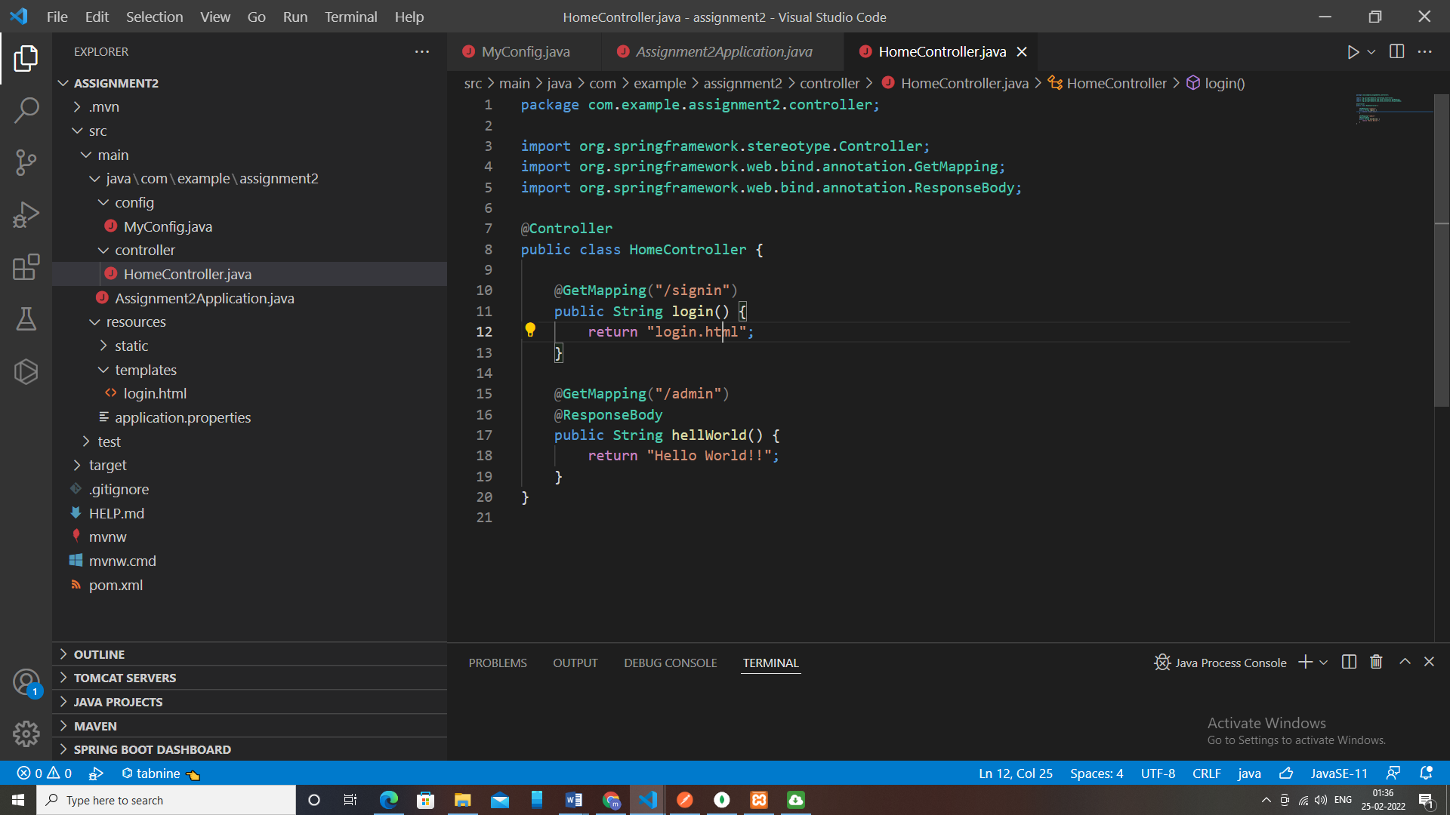

**Configuration:**

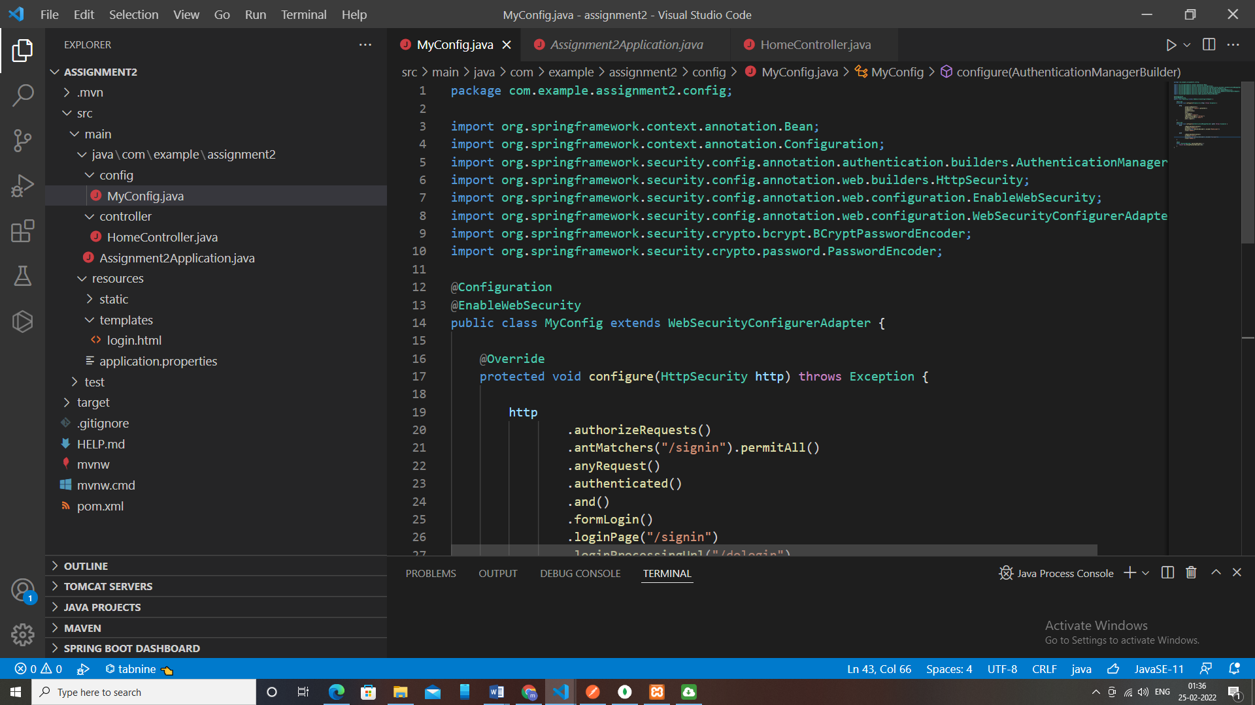

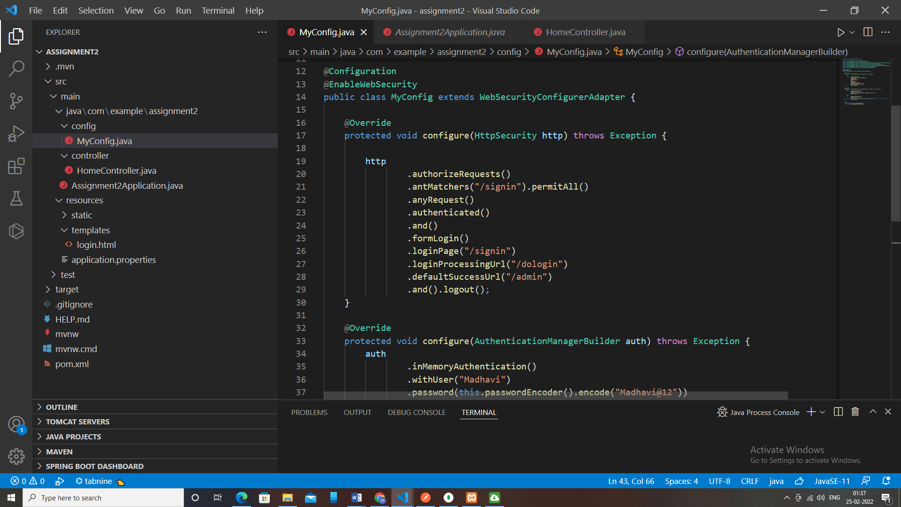

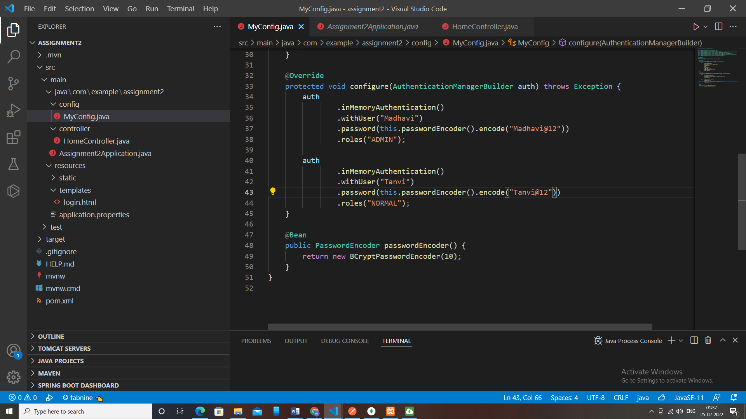

**Custom Login Form:**

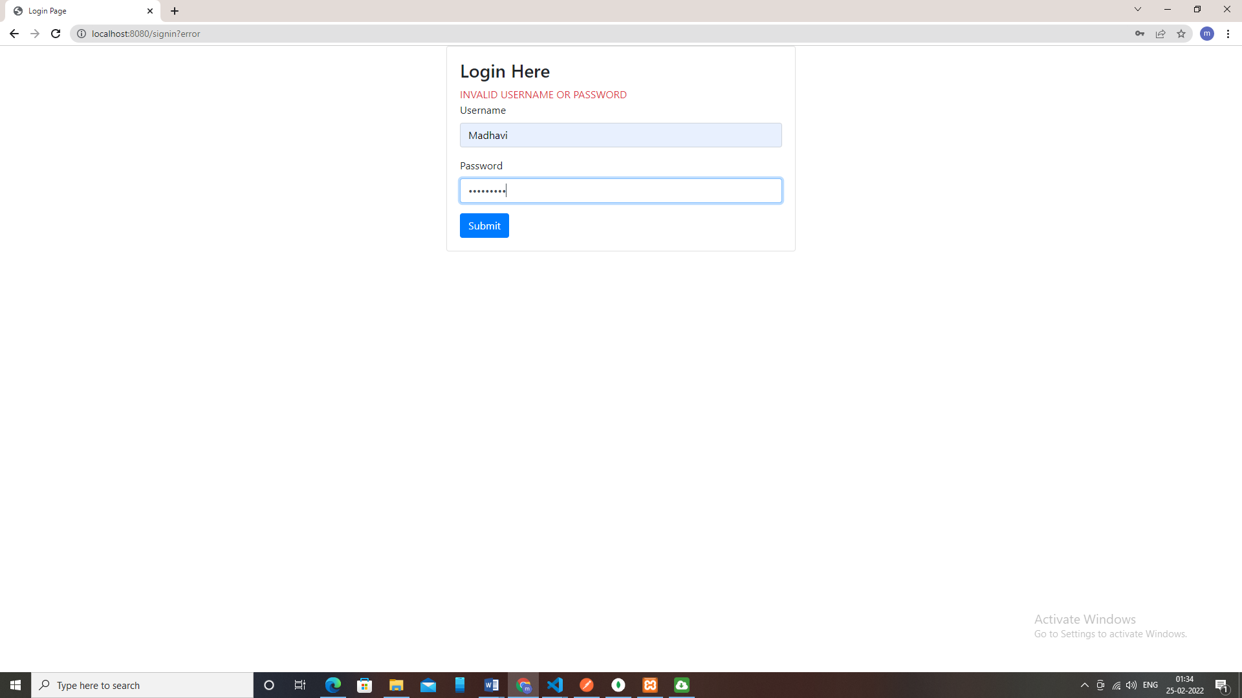

**For Incorrect Username or Password:**

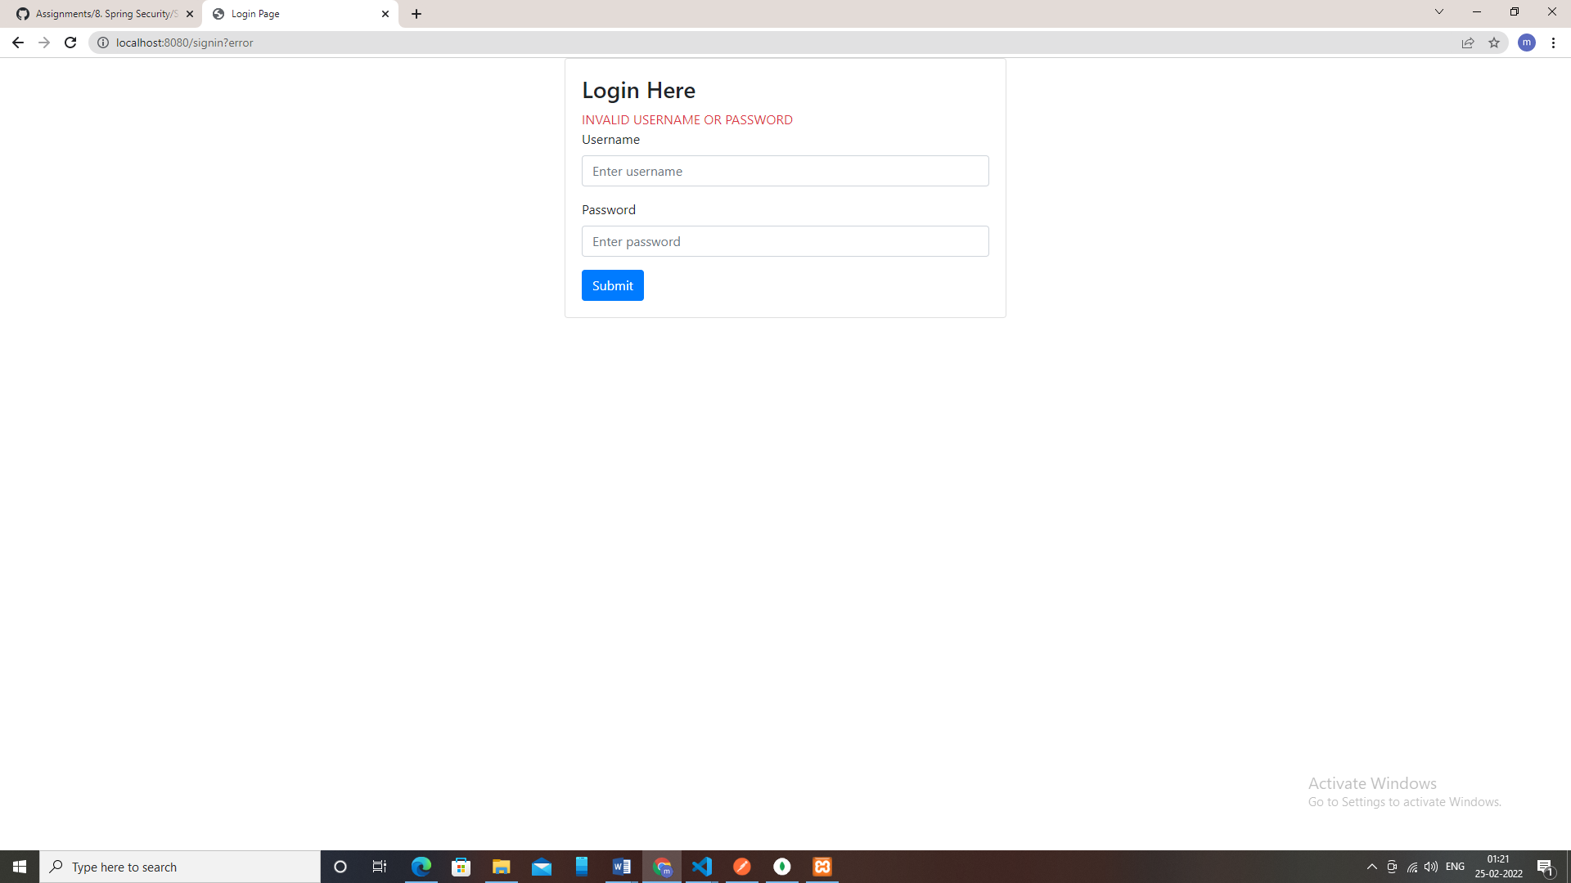

**For Successful Credentials:**

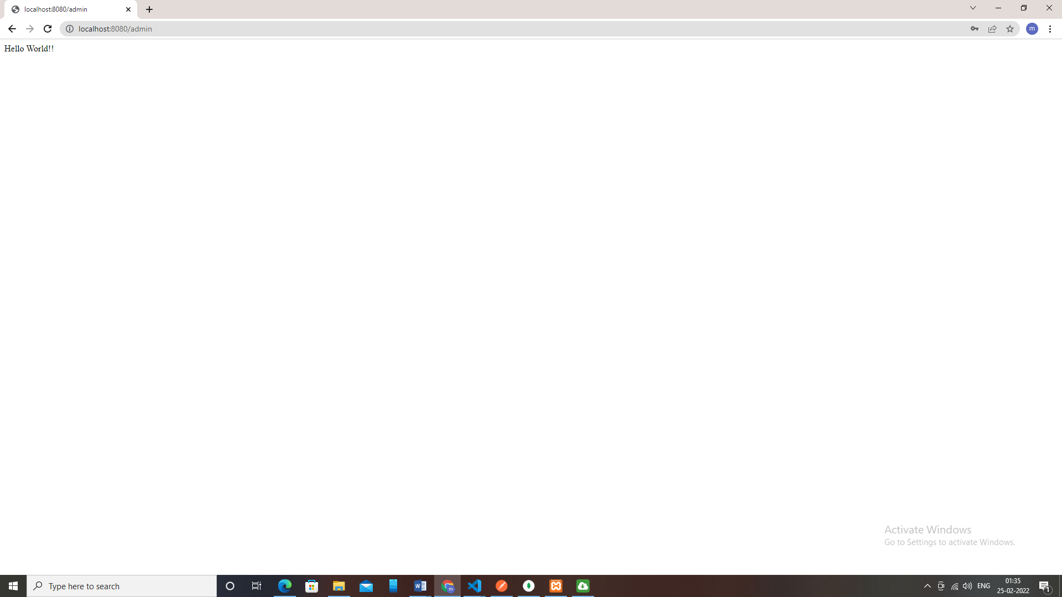

3) Modify the above application and use database authentication using JDBC instead of In-memory authentication.

Use Java Based and annotation based configuration and In-memory authentication.

**Config.java**

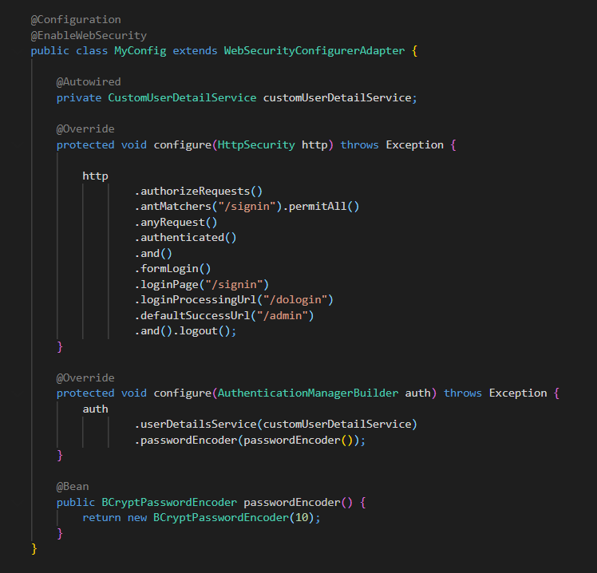

**MySQL Database:**

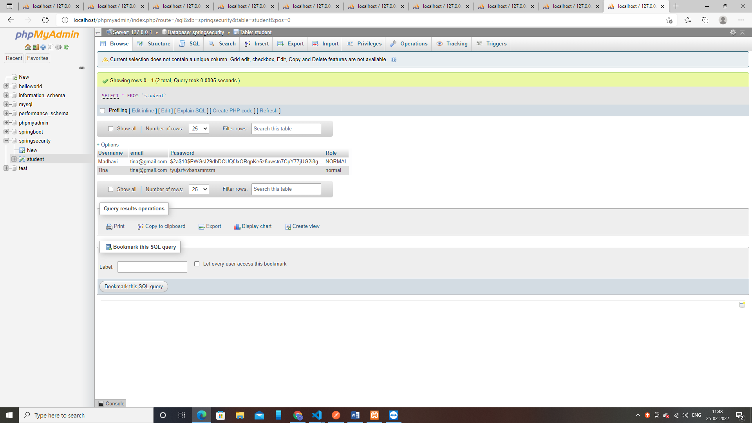

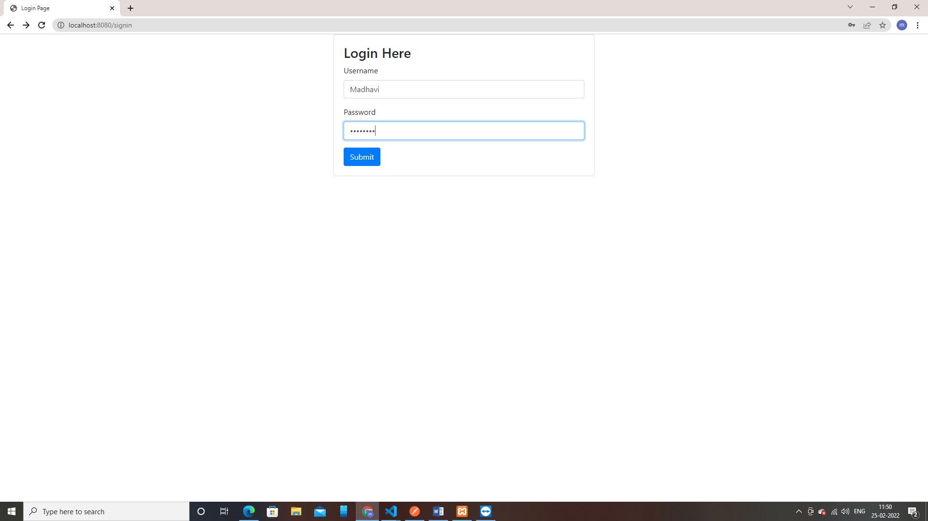

**If Credentials are not matching:**

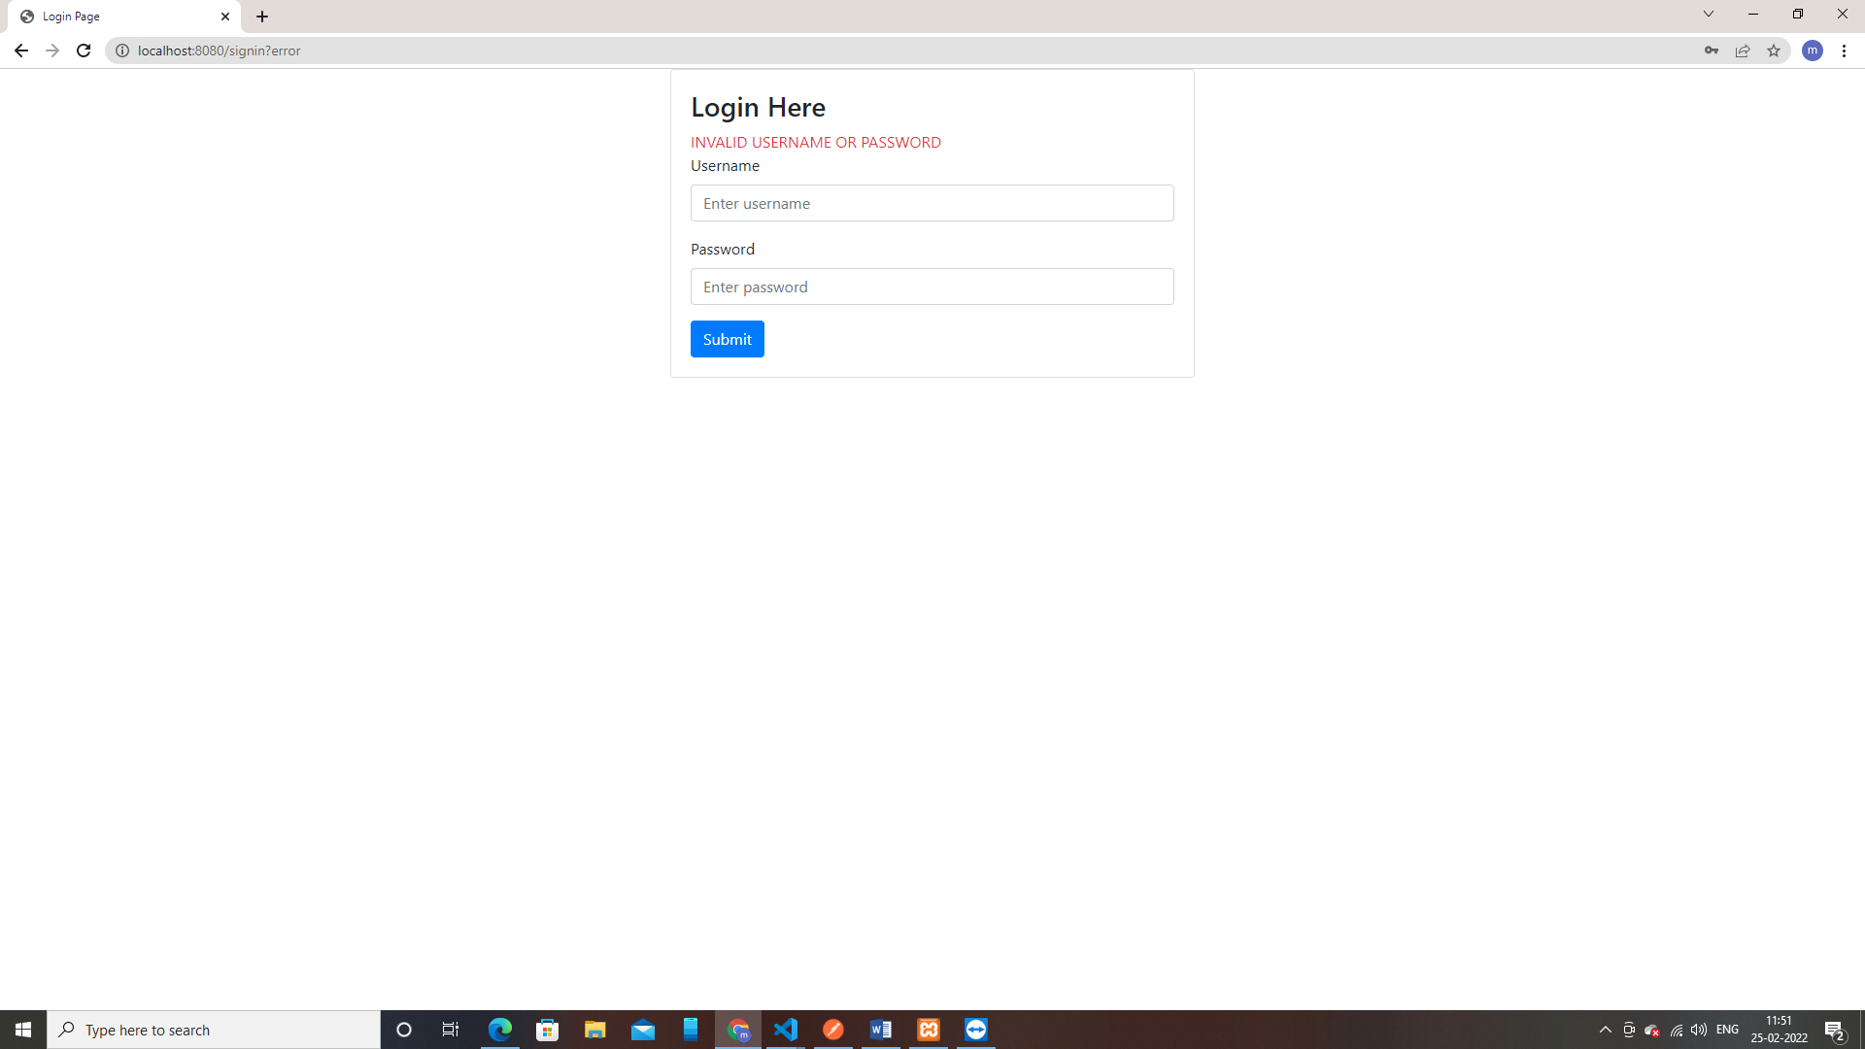

4) Modify the above application to limit the number of login attempts.

5) Modify the above application to implement “remember me” functionality.

**View:**

**Config.java**

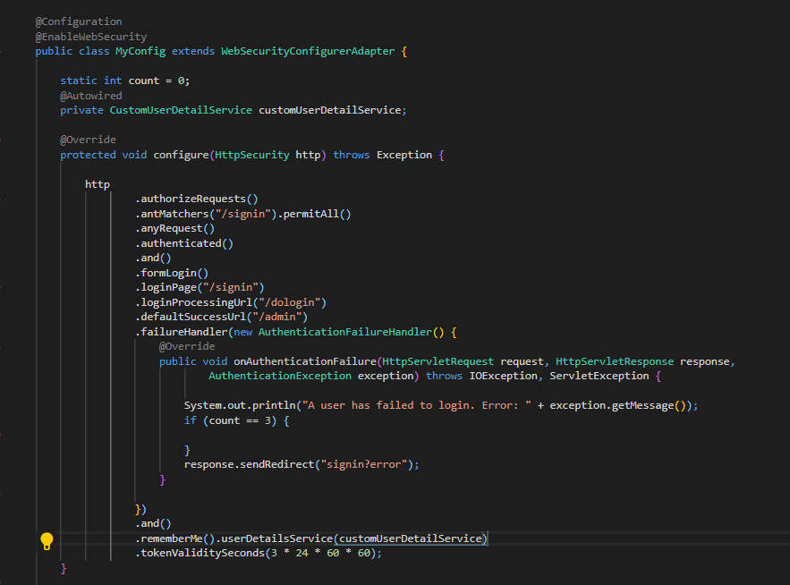

**Hash code of Remember me cookie:**

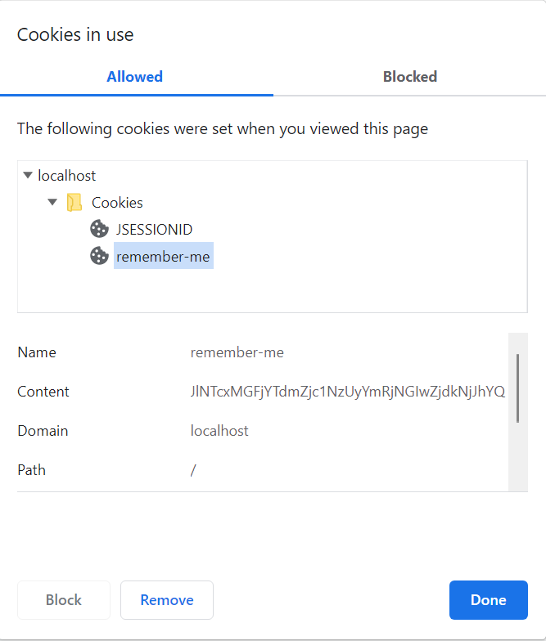

6) Modify the above application to secure the password by encoding it. (You may use some encryption technique)

**Config.java**

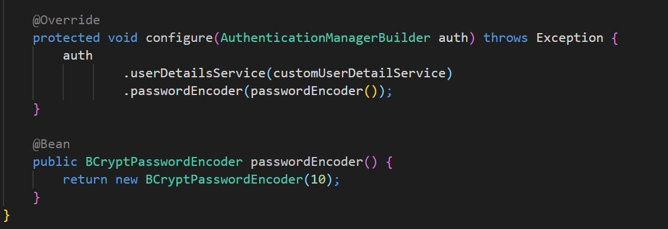

**Encrypted Password:**